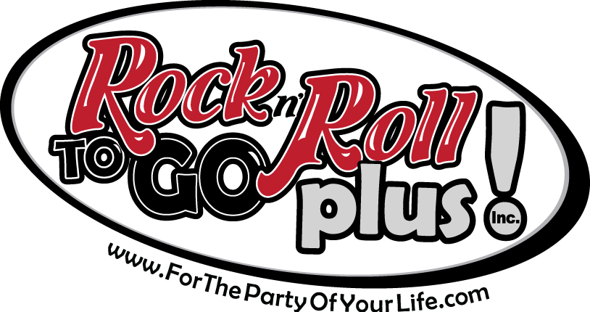
Sponsorship / Partnership
Criteria and Guidelines

In order to make informed decisions on contributions and donations, we ask that your organization complete this form in its entirety. Please return this form to: mark@rnrtogo.com or

Rock n’ Roll To Go Plus! Inc.
1015 E Tyler Ave
Eau Claire, WI 54701

For Rock n’ Roll To Go Plus to consider a sponsorship/partnership agreement, the event/program must meet the following criteria:

1. Have the potential to increase exposure for Rock n’ Roll To Go Plus music, limousines and interactive inflatables.
2. Make a difference in the communities we serve.
4. Provide positive visibility for Rock n’ Roll To Go Plus.
5. Not compromise the Rock n’ Roll To Go Plus integrity or independence.
6. Not discriminate with regard to race, religion, ethnicity, gender, sexual preference or age.

In exchange for event sponsorship, Rock n’ Roll To Go Plus requires the following:

1. Exclusivity
Rock n’ Roll To Go Plus will be the sole music, limousine and/or interactive inflatable partner unless otherwise approved by Rock n’ Toll To Go Plus.

2. Recognition
As a sponsor, Rock n’ Roll To Go Plus will be recognized on all promotional materials, including but not limited to, posters, fliers, programs, tickets, signs, print and broadcast advertising, press releases, etc. Whenever possible, Rock n’ Roll To Go Plus’s logo should be used. The logo cannot be altered in any way (via computer or otherwise). The size of the logo must be in proportion to the size of the ad.

3. Booth space and signage
If the event is one where booths are set up, Rock n’ Roll To Go Plus will be assigned booth space to distribute promotional items, as well as sell fun food items such as cotton candy, sno cones and/or popcorn. In addition, areas will be assigned for display of a Rock n’ Roll To Go Plus banner or banners. Banners should be picked up at Rock n’ Roll To Go Plus office and must be returned, in good condition, within one week after the close of the event, unless other arrangements have been made.

4. Agreement of confidentiality
The specific terms and conditions of sponsorship agreements are confidential. They shall not be made available to any third party without the prior written consent of Rock n’ Roll To Go Plus and the event organizer.

5. First Right of Refusal
Event organizers agree to offer Rock n’ Roll To Go Plus the first right of refusal for event sponsorship the next time sponsorships are negotiated.

Sponsorship Guidelines:
• Rock n’ Roll To Go Plus must be included in all forms of marketing. Failure to comply with this request may result in termination of any/all contractual arrangements previously in existence. All marketing must be approved by Rock n’ Roll To Go Plus via email at mark@rnrtogo.com.

• Rock n’ Roll To Go Plus marketing department will not be responsible for reminding event organizations to provide ad materials or event.

• Photocopies and faxes of Rock n’ Roll To Go Plus logos or art used while marketing Rock n’ Roll To Go Plus will not be acceptable.

• If there is an entertainment, transportation or rental budget, a portion of the budget should be spent with Rock n’ Roll To Go Plus.

• Application for sponsorship must be submitted at least 3 weeks prior to your event. Once application is received and reviewed, you will be contacted within one week. Completion of application does not guarantee sponsorship.

Rock n’ Roll To Go Plus Sponsorship/Partnership Application

Organization __________________________________________________________________________________

Is your organization a non-profit? Yes ______ No ______

Non-Profit Federal Tax ID# ______________________________________________________________________

Years in existence (organization) __________________________________________________________________

Event Name __________________________________________________________________________________

Years in existence (event) _______________________________________________________________________

Date and Time ________________________________________________________________________________

Event Location ________________________________________________________________________________

Target Audience _______________________________________________________________________________

Expected Attendance ___________________________________________________________________________

Is this event a fundraiser? Yes ______ No ______

If yes, how much money do you expect to raise and how will it be used? __________________________________

____________________________________________________________________________________________

Is the event an: Indoor ______ or Outdoor event? ______

Is there an admission fee? No ______ Yes ______ Cost? _______________________________________________

Event contact _________________________________________________________________________________

Address ______________________________________________________________________________________

City _________________________________________________ State __________ Zip _____________________

Phone _____________________________________ Fax ______________________________________________

Email _______________________________________________________________________________________

Advertising budget: ____________________________________________________________________________

Has your organization made a request from Rock n’ Roll To Go Plus in the last 12 months? Yes _____No _____

If yes, what was the nature of the fundraiser _________________________________________________________

_____________________________________________________________________________________________

What type of donation/contribution are you requesting (Cash and/or Equipment)?

_____________________________________________________________________________________________

_____________________________________________________________________________________________

What value will Rock n’ Roll To Go Plus receive in return? _______________________________________

____________________________________________________________________________________________

Please include or attach a list of all other media and event sponsors: ______________________________________

_____________________________________________________________________________________________

_____ I have read a copy of Rock n’ Roll To Go Plus Sponsorship/Partnership Criteria and, if approved for a sponsorship or partnership, I agree to comply with the noted guidelines.

If there is an event sponsorship package, please include a copy with this request.

_________________________________________
Name

_________________________________________
Title

_________________________
Date

